Spring-Mass3D Log

With point-mass

try to simulate and get the error:

[1] 12:47:09 Symbolic Error

[Modelica.Mechanics.MultiBody.Parts: 1873:7-1885:3]: Assertion triggered during translation: "

A Modelica.Mechanics.MultiBody.Parts.PointMass model is connected in

a way, so that no equations are present to compute frame_a.R

(the orientation object in the connector). Setting frame_a.R to

an arbitrary value in the PointMass model, might lead to a wrong

overall model, depending on how the PointMass model is used.

You can avoid this message, by providing equations that

compute the orientation object, e.g., by using the

Modelica.Mechanics.MultiBody.Joints.FreeMotion joint.

If a PointMass model is not connected at all, the

orientation object is set to a unit rotation. But this is

the only case where this is done.

".

Replace point-mass with Body (single connection)

Simulate with no changes except entry of value for spring constant and mass. Worked with initial condition warnings.

Tried to set spring constant programmatically,

parameter Real springDamperParallel1.c = 1.2; (with or without the "parameter" declaration, Got error:

[Spring3d: 5:39-5:39]: Missing token: SEMICOLON

To get equilibrium initial condition, put CoM at restLength + mg/c = 0.5+ 0.75*9.81/1.1 = 7.18863636

r_0(start = {0, -7.18863636, 0}, fixed = true) ... this works

Next - how to set this up automatically?

First, resolve all of the initial condition warnings (“9 variables”)

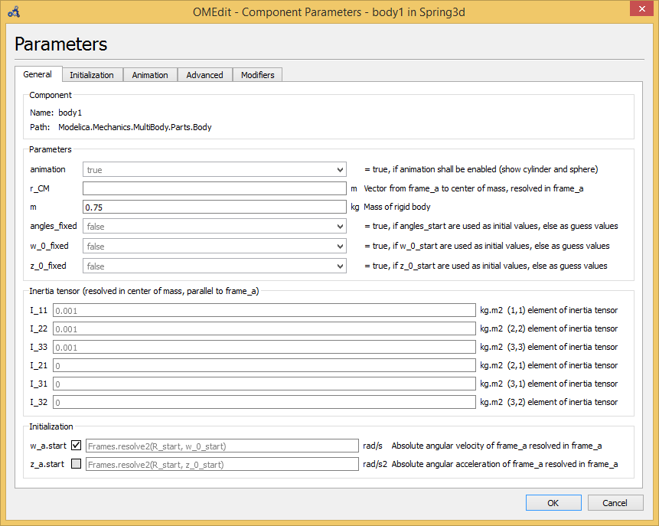

w_a.start (see figure, above) set to fixed. This reduces initial condition warnings to 6, simulation works.

Z_a.start set to fixed. Reduces warnings to 3 variables, but simulation fails with lots of errors like “matrix singular). Set it back to default (gray, “inherited, false, start value is only a guess value”). Setting it to white, same as gray but without the “inherited” works also. Still 6 variables in warnings.

w_zero_fixed to true – no reduction in variables in warning, simulation works, set back to false.

z_zero_fixed to true – no reduction, simulation works, set back to false

angles_fixed to true – reduces warning variables to 3, simulation works, leave it on true

Switch to Initialization tab:

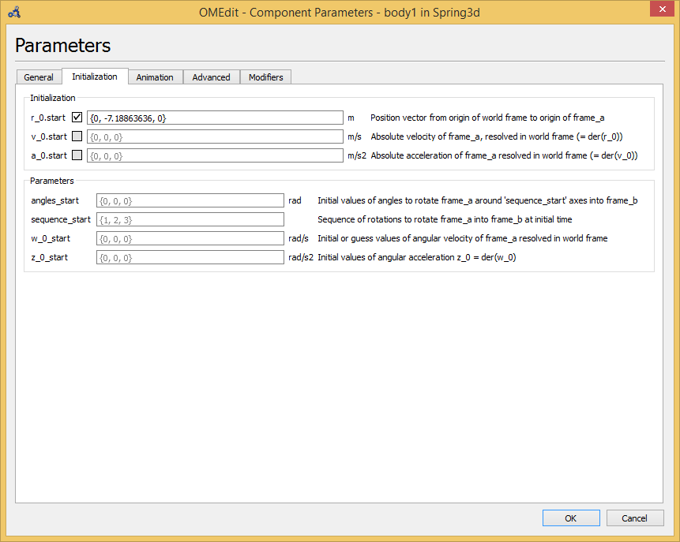

Set v_0_start to fixed – no more initialization warnings, simulation works.

Warning about CM not set:

[Modelica.Mechanics.MultiBody.Parts: 659:5-660:67]: [Parameter body1.r_CM[1] has no value, and is fixed during initialization (fixed=true), using available start value (start=0.0) as default value.](omeditmessagesbrowser://Modelica.Mechanics.MultiBody.Parts?lineNumber=659)

Set r_CM to {0,0,0} (first screen) – got rid of that warning, simulation works.

Final warning left:

[Spring3d: 4:92-4:104]: [Non-array modification 'true' for array component, possibly due to missing 'each'.](omeditmessagesbrowser://Spring3d?lineNumber=4)

Not sure where this comes from – I’ve seen it often. I read somewhere that it may be an internal error in the MultiBody package???

Next, I really want Modelica to figure out the initial condition itself so that the Body start out in an equilibrium condition.

First try: set r_0.start to false and set a_0.start to true. Didn’t work – lots of division by zero, didn’t simulate even though it said the simulation succeeded.